MEN. BEAUTY & CARE. GAME ON THROUGH TECH, PRODUCTS AND BEYOND
It’s time to rewrite the rules of Beauty & Care. Men need to be as invested in looking and feeling their best and deserve products and routines that speak directly to them. This is your chance to create a future where men’s grooming takes center stage. Are you ready to break down stereotypes and empower men to embrace self-care?
Judging Criteria:
At each step, the projects will be evaluated out of 25 points. The weighting of the evaluation criteria is mentioned below

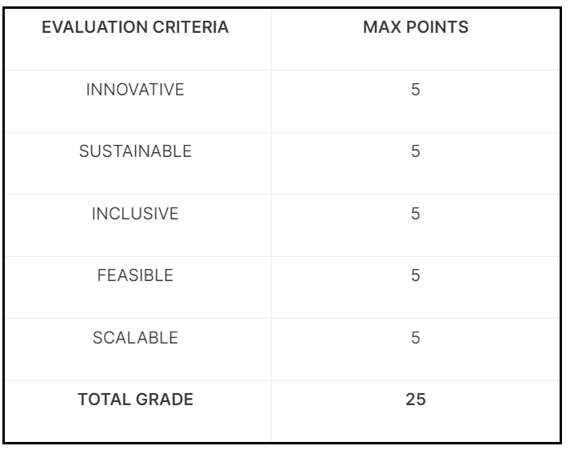
What are we expecting from you?
- Innovative - We want your team to be bold and bring to the table products and solutions never seen
before.
- Sustainable – We want your team to take responsibility and be mindful of the impact that your project will have on the planet.
- Inclusive – We want your team to be mindful of diverse needs in our society to not exclude any
particular social groups (gender, sexual orientation, socio-economic and multicultural origins, people with disability, all ages & generations...), and to make your project as equally accessible as possible to all potential users.
- Feasible – We want your project to be realistic and possible to implement.
- Scalable – We want your team to present a project realizable on a big scale.
Star Pattern
Situation
Task
Action
Result
Sources from online, vids, ppts
Power BI
3 min business proposal, what is to be done?
Focus on Men Beauty & Wellness: men that we care about don’t like skin care, etc. they need something quick, no need for 10+ products to maintain their beauty,
Ideas: include Beard, generative ai as a guide to their wellness, before & after AR, virtual make up room, circular economy in packaging material, safe & afforadable small makeup kits, something for gig workers, adaptive makeup kits for differently abled & other communities, reusable delivery packaging material,
Analysing skin tones, body features to recommend suitable outfits & virtual try-ons
Ai driven AR virtual reality closets in malls & loreal outlets to provide recommendations based on facial structure (+ mobile app if feasible),

